**Final Project Report**

**HK Play Around**

<https://hewenwei038.github.io/final_project/>

He Wenwei

1155134442



**Contents**

Introduction 1

Strategy 1

1. Users’ needs 1

Scope 3

1. Users’ journey map 3

2. Point of view table 3

Structure 4

Skeleton 5

1. Wire-frame prototype 5

2. Usability Test 10

Surface 11

1. Surface screenshots 11

2. A/B testing 14

3. Data Dashboard 16

Conclusion 17



Introduction

Several months ago, I watched a news according to a report conducted by The Boys’ & Girls’ Clubs Association of Hong Kong in 2019 It said that 54% of the children play less than 1 hour in school days and 25% in non-school days. Moreover, over a half (55.6%) of children never or seldom play outdoor (public playgrounds/parks) and only 30.8% of the parents supported playing thought by their kids. This news aroused my interest toward the issue of playing outside since I remember when I was a kid, playing outside should not be a difficult problem for me and my family. Then I found out another survey conducted by the Hong Kong Society for the Protection of Children in 2017 mentioned that many parents lack the information about the public children facilities in Hong Kong. There is only the website of showing the information of some children facilities, which is simple and not attracted at all.

In foreign country, parents can use an APP called “Playground Buddy” to get the information about the playgrounds nearby. So, I wanted to build up a data-driven website combining design thinking and computer thinking to attract more parents to bring their kids outside, discovering different funny children facilities all around Hong Kong. The date mainly based on data.gov.hk and this report reflects the whole process of the website.

Strategy

1. Users’ needs

In this project, I mainly target the local parents whose kids are from 0 to 12 years old, and they want to find satisfied children’s facilities to spend time but with limited budget. The secondary target users are those travelling parents with kids from 0 to 12 years old (see Table1).

|  |  |  |  |  |
| --- | --- | --- | --- | --- |
| **Site Objectives** | | **Target Users** | | **User Needs** |
| Primary Goal | Establish a guideline of public children’s facilities in Hong Kong | Primary User | Local parents with kids from 0 to 12 years old | Find Children’s facilities to spend time with their kids on weekends. |
| Additional Goal | Increase parent - child tourism experience | Secondary User | Mainland/Overseas parent – child travellers | Find Children’s facilities when they are travelling in Hong Kong. |

Table1

In order to get more details about what they really need, firstly, I established a post in baby-kingdom.com which is the largest online parent’s forum in Hongkong. The parents responded enthusiastically and the feedbacks were quite useful. I received 30 feedbacks of these three simple questions within 4 hours.

**Q1: How do you find the public children’s facilities in Hong Kong?**

**Q2: Are there any problems when you find the public children’s facilities in Hong Kong?**

**Q3: What does you care most in public children’s facilities?**

For the Q1, most parents commented that they found the public children’s facilities just nearby or through recommendations from friends, and some said that they will google it. As for the Q2, some parents mentioned that sometimes they want to know more details about the facilities so that they search in engine or government website but the information was messy, limited and useless. There were several key words they mentioned in the Q3 such as “big size”, “convenient transportation”, “specific facilities like ‘摇摇板’ and ‘千秋’” and “suit for which age”.

Later, for the secondary target users, I draw out the similar three questions but change the situation to when they are travelling. I asked my relatives and classmates who have kids from 0 to 12 years old to get their answers. The similar answers were showed in the Q1 but more parents used internet to search than the previous. For the Q2, they both said it was difficult to find the public one especially since the App like 大众点评 always had the information about private children facilities. Nearly the same things were answered in the Q3.

**Scope**

1. Users’ journey map

Receiving the comments in baby-kingdom.com and the feedbacks in my simple quality researches, I basically sketch out the general concepts of how they prepared, chose and set out to the children’s facilities. Later, I collected and combined their points of view, building up a rough journey map (see Figure 1) for me to find out the chances of my webpage.

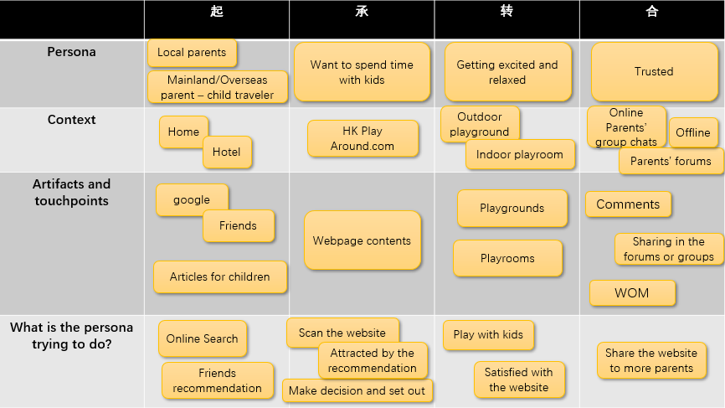

Figure1-*Journey Map*

1. Point of view table

I therefore summed up the user’s needs and the journey map, and generate the point of view table to better be excavated (see Table 2). As what I have said before and the table below, the needs of the children facilities are very specific, detailed and personal, so I adopted the insights of them. A personal choice section and the recommendation part mostly based on the needs they mentioned are built in my website.

|  |  |  |
| --- | --- | --- |
| **Persona** | **Needs** | **Insight** |
| **Mother with a 5 years old boy.** | **Playground with swings.** | **Her kid love playing swings.** |
| **A full-time Mother with 2 kids.** | **The information of playground suited for which ages.** | **Her kids are not willing to play the ‘silly’ facilities anymore.** |
| **Father with 2 boys.** | **Playground with seesaws** | **It is hard to find seesaws in the playground right now.** |
| **Mother** | **Big size of the playground.** | **Some playgrounds or playrooms are quite crowded and the kids have to wait for quite a long time to play.** |
| **Mother with 2 girls and a boy.** | **Playground have toilets.** | **Kids always sweaty and have multiple problems when they are playing outside** |

Table 2- *Point of view table*

In short, the problem statement is how can we help the parents get to spend time with kids in different ages, preferences and requirements, aiming to find out their personal needs, become more efficient and improve parent-child relationship?

Structure

After the basic problems I had found out, I started to conduct a brief structure of the website. Most of the parents are quite busy and they do not have too much time to surf something in the computer. So, I decided to adapt a single-page website which is more users’ friendly, efficient and simplicity to scan in a mobile phone. Setting up a website always wants to attract and engage the users to use it. The more it relates to the users’ journey map or problems; the more visitors will use it. Therefore, I made specific analysis in the second step of the journey map “Want to spend time with kids”, which includes three parts in parents’ mind, so I conducted the structure initially based on “Preparation-Decision-Set Out” timeline (see Figure 2).

Figure 2-*Structure*

Through the answers I gained in the questions, many parents went to the children’s facilities nearby. In the preparation part, I divided the facilities into personal choices, which is easy for the parents to know the specific facilities. But many parents also mentioned they care much about the detailed things such as size, population, theme and so on. With these targeted aims, parents can make decision in the“主題特色” and “精选推荐”, which are showed in specific. Finally, they can set out with the map. In addition, a fixed-navigation bar was set for them to switch to different stages easily and find out the desirable one.

Skeleton

1. Wire-frame prototype

Mapping out the basic structure, I draw a wire-frame prototype to demonstrates the content in each part and establish a very original outlook of my website page. The wire-frame prototype is shown as following (see figure 3-10).



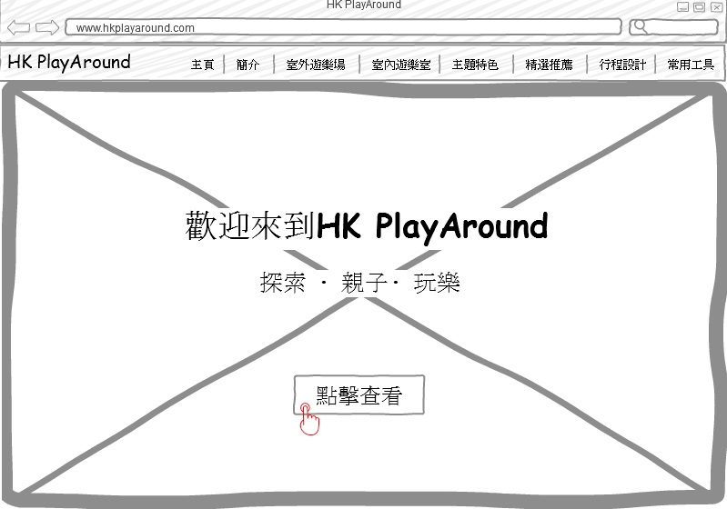

Figure 3



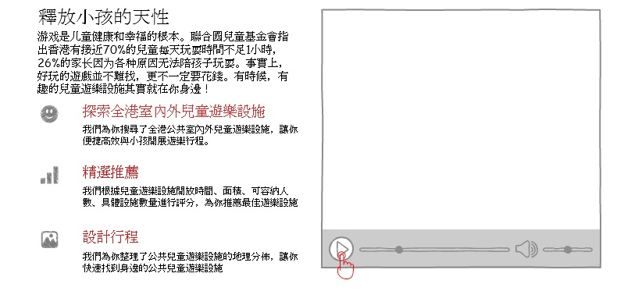

Figure 4





Figure 5



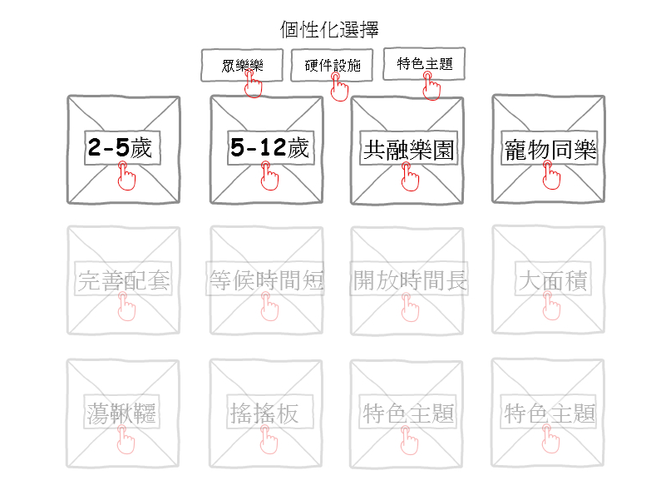

Figure 6

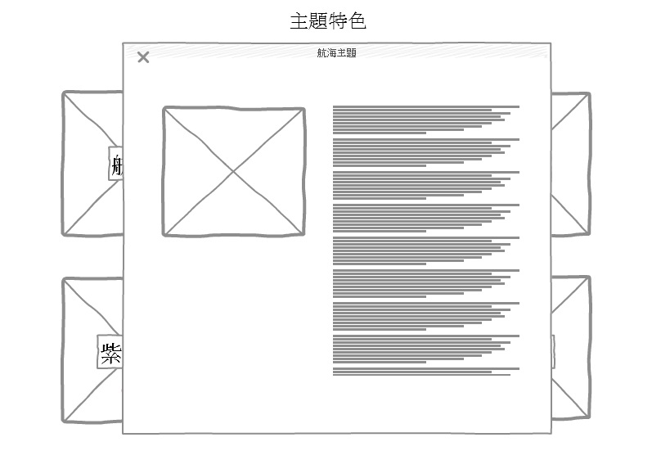

個性化選擇

Figure 7



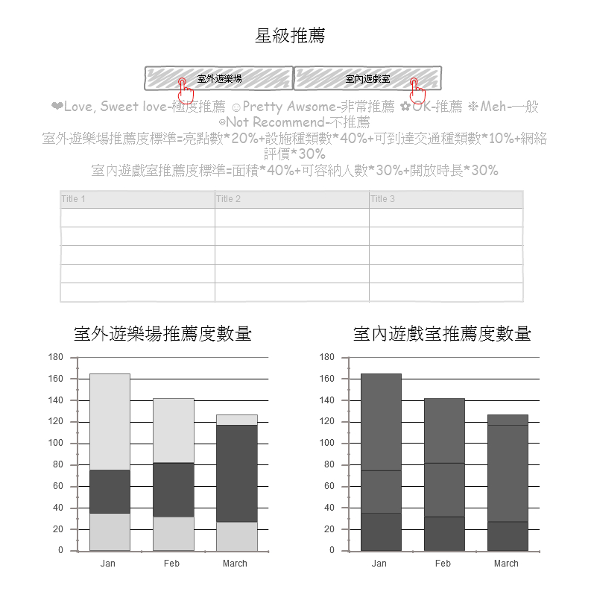

Figure 8



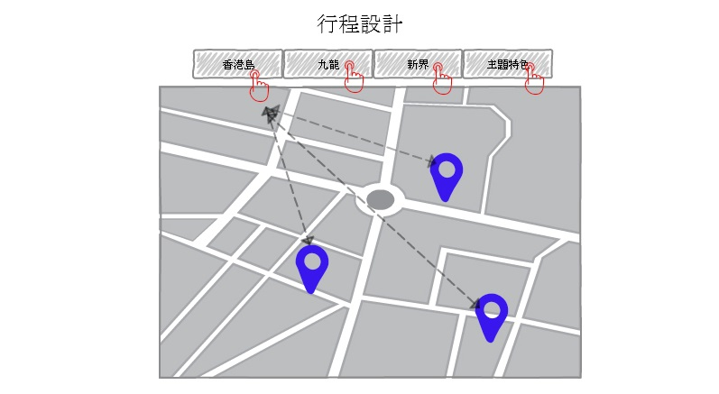

Figure 9





Figure 10

The single-page website is separated into 8 main parts. I chose a picture fulfilled the first and main visual page because it is very attracted and eye-catching. There are three short words in the picture, which are “探索”, “親子”, “玩樂”. These three words cover the goal that parents can explore more children’s facilities which actually are funny and free to spend more time playing with their kids, improving the parent-kid relationship. As I mentioned before, the facilities firstly were the overlook. Visitors can click the button to have a brief knowing in a gallery view. Next, the personal requirements are listed, visitors also can click and an individual panel is showed up containing detailed introduction, Visitors not only can make decisions based on the themes or specific requirements, but also can refer to our recommendation below. Finally, they can move to the map and get setting out.

1. Usability Test

I invited 5 targeted volunteers to participate in my usability test. I asked them the following questions:

**Q1: How would you start to view the website?**

**Q2: How would you find a playground for 2-5 years old kids?**

**Q3: How do you find children’s facilities with the themes?**

**Q4: How do you get the ranking of the facilities?**

**Q5: How would you see the location of the facilities?**

Most of the volunteers viewed the website by scrolling without hesitation, and they were seemed that they cannot figure out he button in the main page. So, I would like to change the colour of the button in the A/B testing, seeing which one is better. All volunteers can figure out and finish smoothly in Q2, Q3 and Q5. For the Q3, two volunteers clicked through the link of “精選推薦” in navigation rapidly, and one volunteer choose it in the introduction page (see figure 3). She said she normally preferred to scan and know more details then turn to the recommendation. The rest of them thought quite a long time but still click the “精選推薦”, they said they guessed it should be there. After finishing these four questions, I asked them what should I put in the “常用工具”, and some suggested me to put some tools such as the metro route and weather forecasting in it since it would be quite useful for the non-local people.

Based on the test, I made some changes in the webpage. At first, I change the name of “精選推薦” into “星級推薦” (see figure 11), which seemed to be better understood. And then, I added some details in the link of “常用工具”(see figure 12).



Figure 11



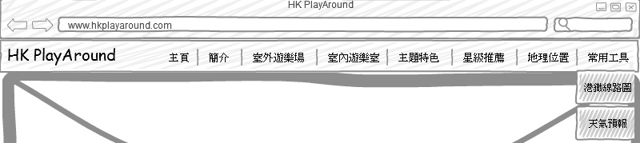

Figure 12

Surface

1. Surface screenshots

After several weeks of coding, the webpage was finally finished and all the functions were successfully delivered. I chose orange as the main colour since orange is the warmest in all the warm colours, which represents friendly and active. What is more, it is also a motivative colour that can encourage parents to bring their kids go outside. The following screenshots (see figure 13-19) are displayed in my laptop and the whole website is also responsible for all devices, you can see more details via the website link:

<https://hewenwei038.github.io/final_project/>

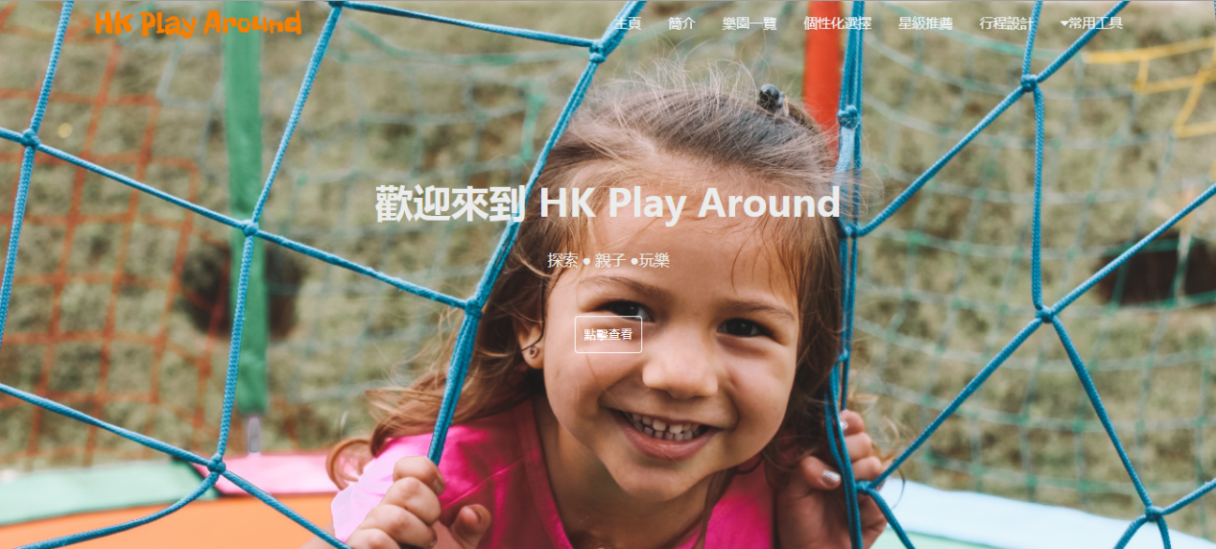

Figure 13-*The main page*

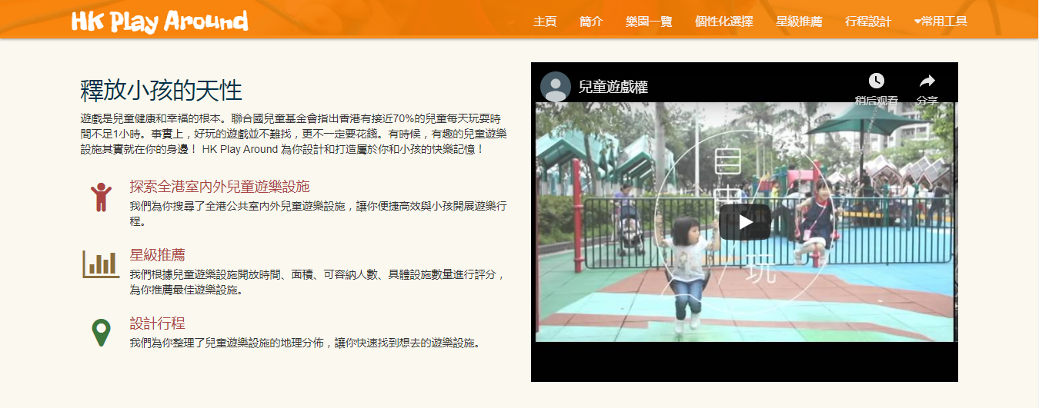

Figure 14-*The introduction page*

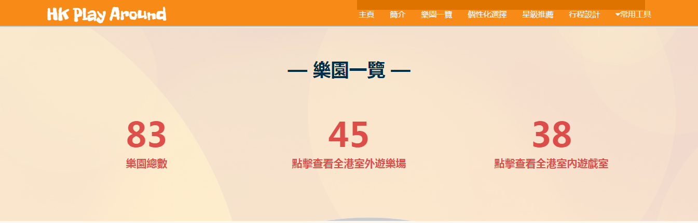

Figure 15-*The general page*

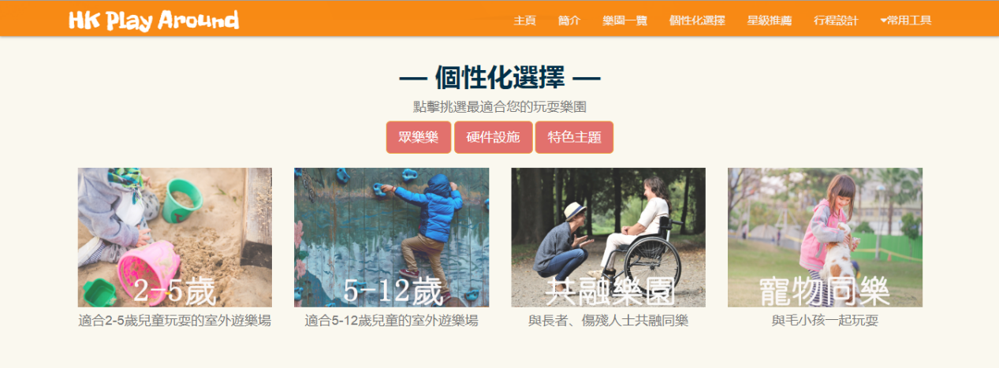

Figure 16-*The personal choices page*

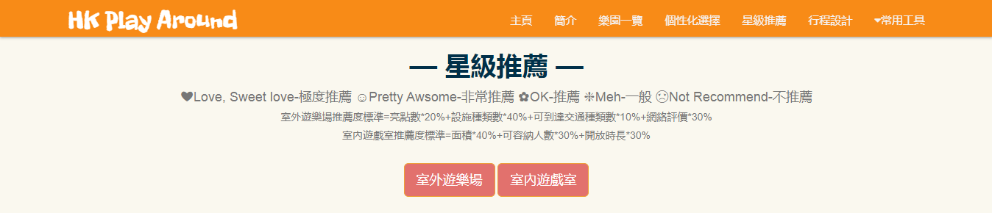

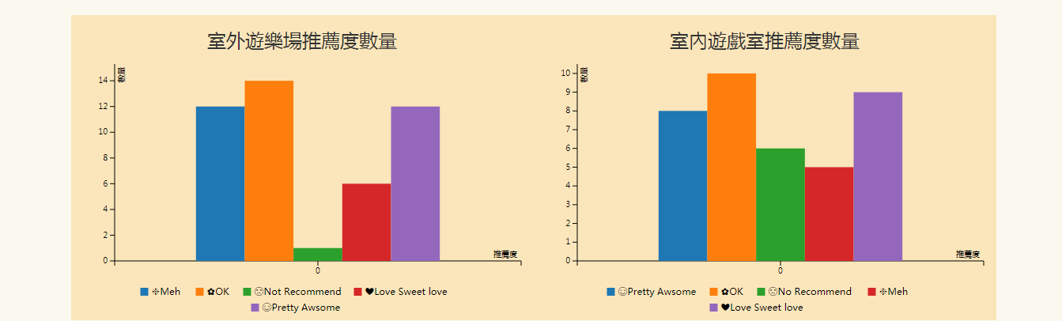

Figure 17-*The recommendation page*



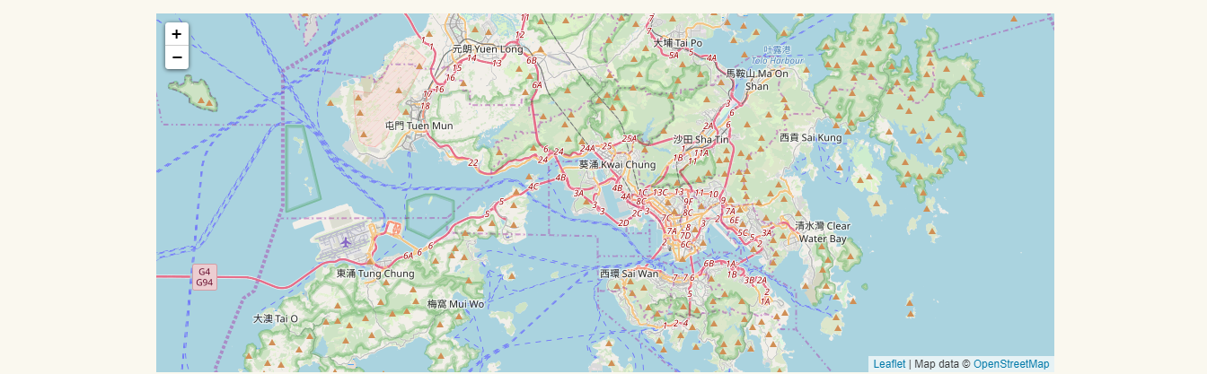

Figure 18-*The map page*



Figure 19-*The footer*

1. A/B testing

In the A/B testing, I changed the main page style in my website (see figure 20-21). The first one is the picture in the first sight. The picture of a girl’s smiley face was changed into a boy playing swing. The second part was the button colour which was from transparent into orange.

The result in the Google Optimize are shown below (see figure 22). Obviously, there was a change when more and more visitors click into the page between 30th September and 1st November. The version B started having better performance in this period. In my view, the button colour properly played the important role in this change. Compared to the transparent colour, orange colour is more outstanding upon the great picture. Other changes maybe happen since the inversion-rate lines in the graph are getting closer, but because of the limit of time, they cannot be shown.

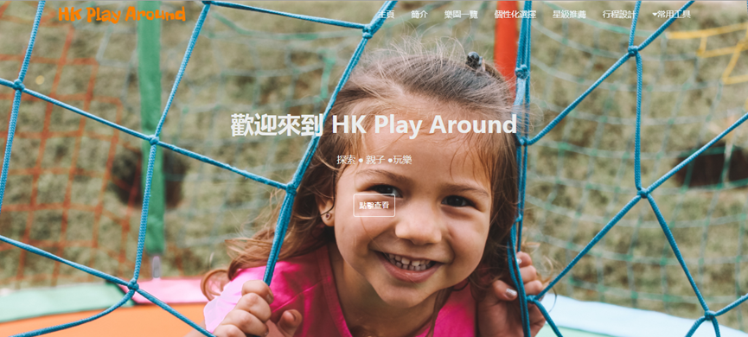

Figure 20-*Original Version*

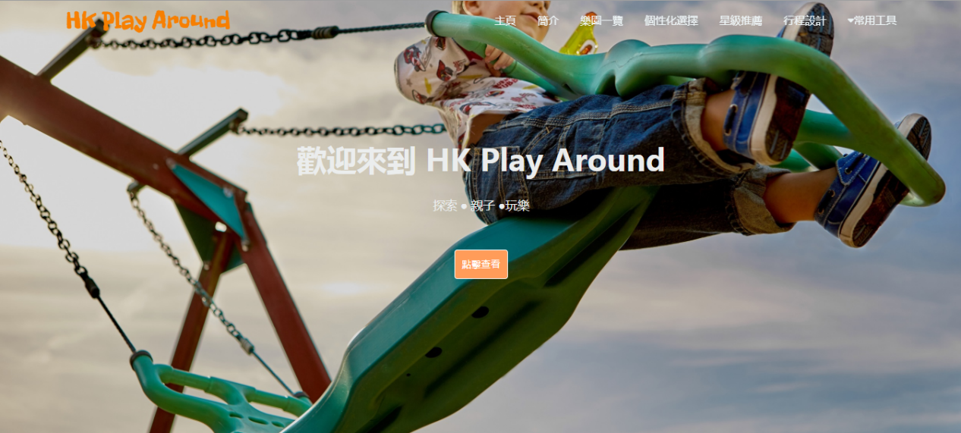

Figure 21-*Version B*

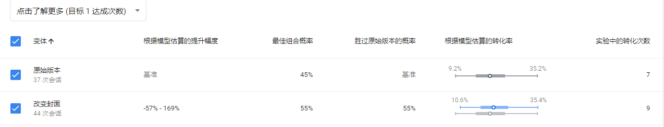

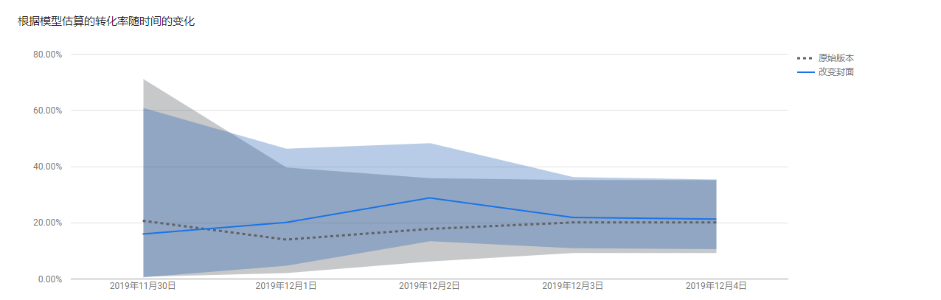

Figure 22-*Result of A/B Testing*

1. Data Dashboard

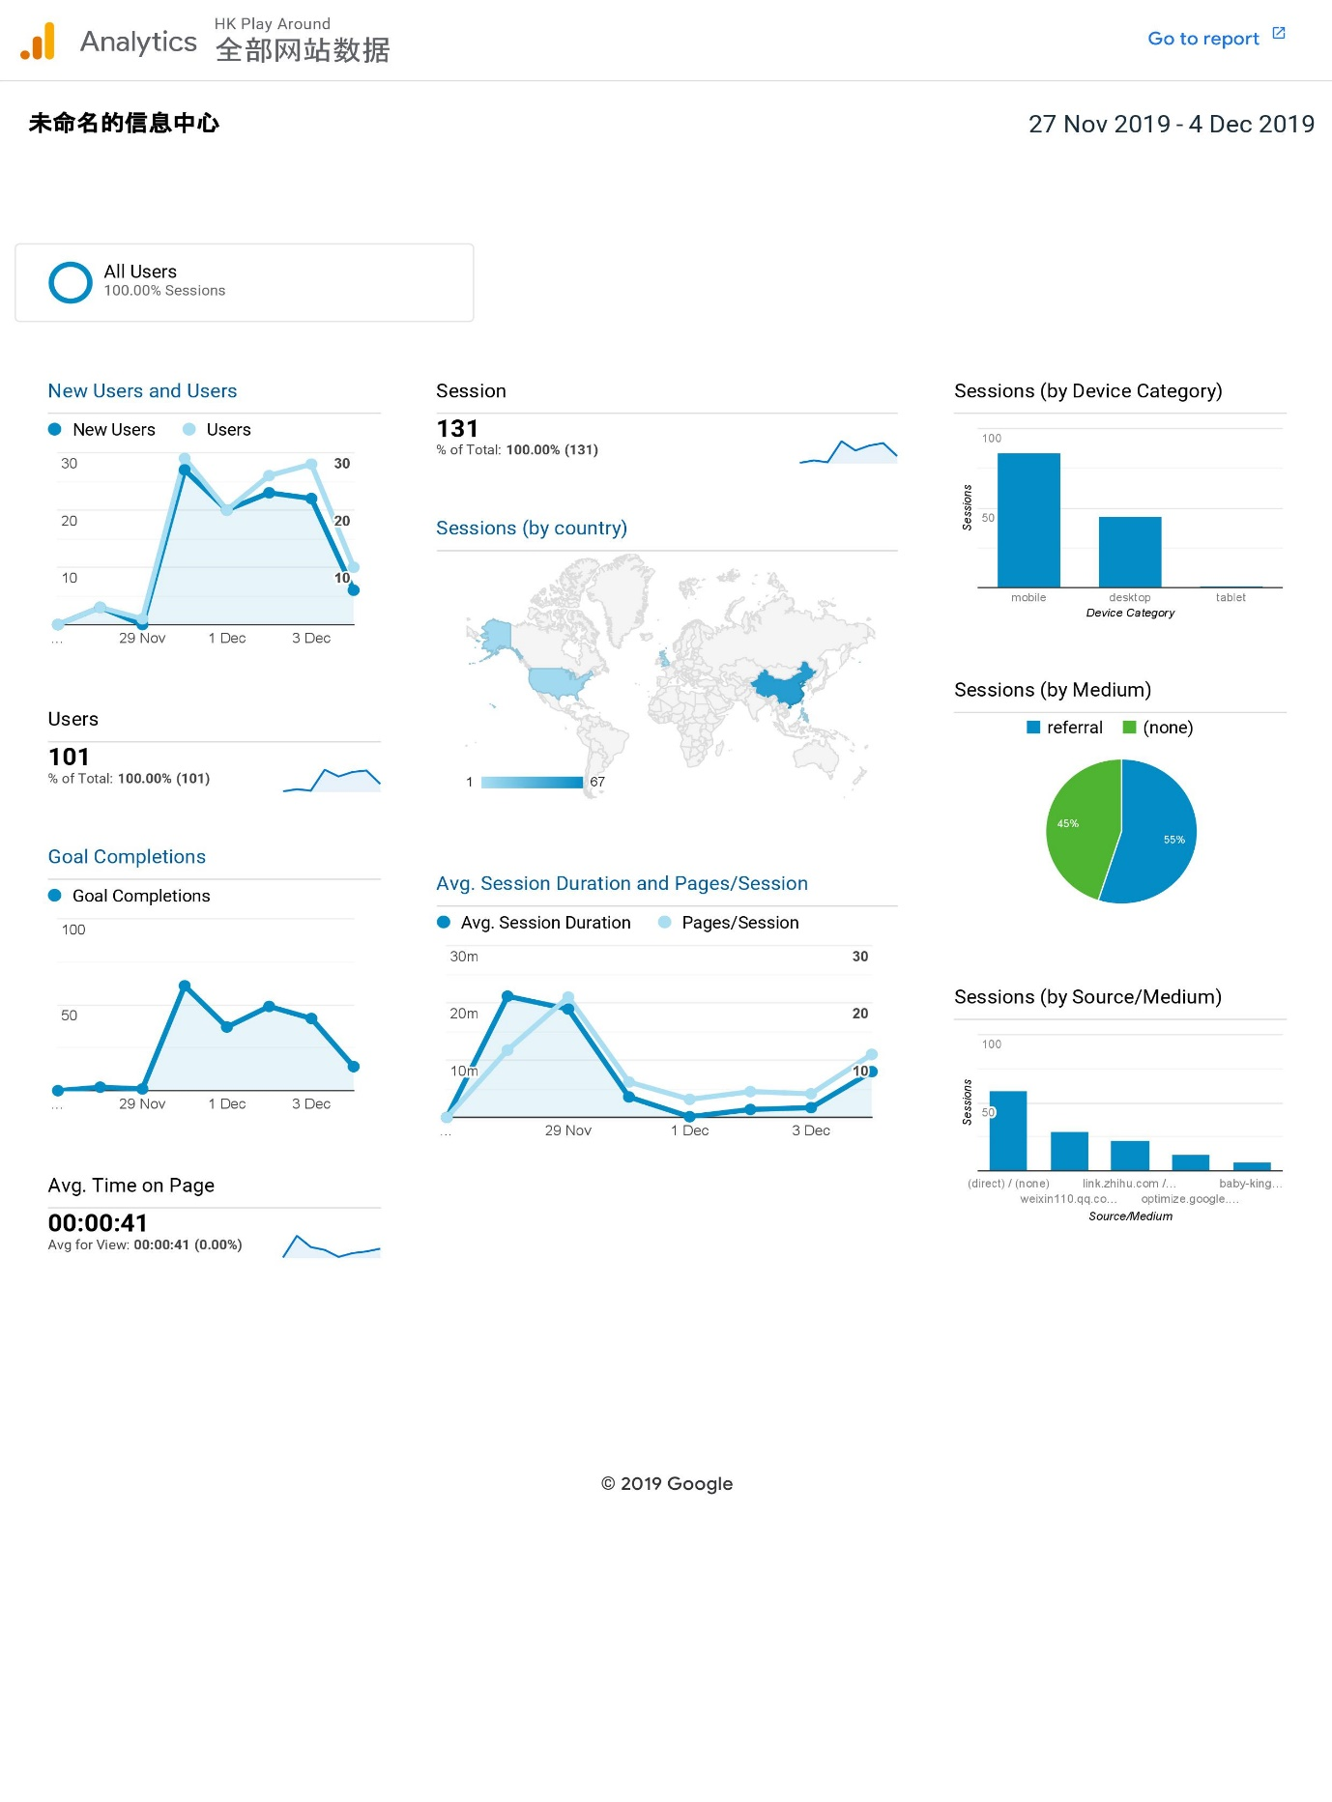 Figure 23-*Dashboard 1*

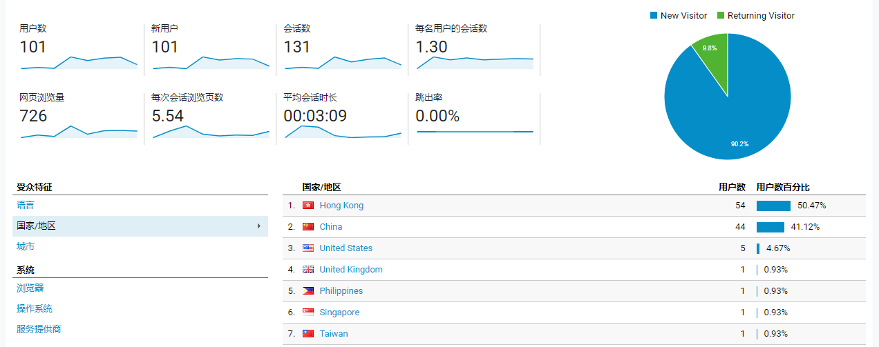

Figure 24- *Dashboard 2*

From 27th November 2019 to 4th December 2019, Google Analytics had collected the data from my website and it also generate dashboards which are direct, clear and visual to show the outcomes of my website. Total 101 users visited my website through this period and 9.8% of them returned. This result was quite satisfied to me because it meant that my website was really attracted for some people. But at the same time, the average time on page was just 41 seconds, reflecting that there were some problems in my website such as the contents or the design. The bounce rate was quite strange, and the problem needed to be figured out.

HK Play Around is a website mainly targeting the parents. In these eight days, I mostly paid attention into three mediums. The first one is the baby-kingdom.hk forum where I got most information about parents and kids in the first beginning to set up this website. I published 3 post with the URL link of the website in three different time quanta. As a result, I found out that parents clicked into the link more in the evening especially in the late night. The reason probably is that they have free time to surf the net after their kids get to sleep. Second, I also posted the link in some WeChat groups which were composed of CUHK alumni. Lastly, I also shared my link in Zhihu.com. Therefore, 55% of the sessions was from referral.

I totally set up 6 goals in Google Analytics. Each goal was completed under certain circumstances. The goal of clicking the personal choices and recommendation links were completed the most, both were over 40 times. But the goal of watching the video was 0, and I thought there was some problems when setting this goal.

Conclusion

In the beginning, I conducted a very preliminary prototype based on regions but Bernard told me should spend more time on the users’ needs. Then, I revised all the comments and the interview drafts finding that actually the user already told what they really want but I did not indicate them in the website. I therefore changed some parts to be better cater to their needs. It was definitely a precious experience and moment for me since I could not image that I can build up a whole website by myself. This semester was tough but harvest, not only I learnt technique about coding, but also the art of thinking.